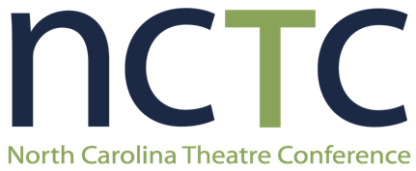
(School Name) Celebrates Participation in the 2026 NCTC High School Play Festival!
(Date) – The Theatre Department at (school name) is celebrating their recognition in the 2026 NCTC High School Play Festival. The theatre program, led by (teacher name), presented (show name) at the Festival, and is bringing home the following awards: (list awards).

This year, over 2,500 students from more than 90 schools are performing 126 plays at 8 regional sites. The top 16 productions are invited to perform at the NCTC State High School Play Festival, November 19-20 at Greensboro College.
Participating schools travel to their regional Festival sites with theatrical sets, costumes and props. Each show loads into a 10’x10’ backstage area. When their time comes, schools have 45 minutes to set up, perform the play, and clear the stage. Following their performance, students receive feedback from professional actors and directors with Broadway and Hollywood credits. Awards are given for acting, design, technical craft, ensemble work, and festival spirit.
“The Play Festival continues to exemplify the spirit of community and collaboration, providing students with an inspiring environment to learn from one another and lift up each other’s work,” said NCTC Executive Director Angie Hays. “Participants leave the festival with a deep sense of accomplishment, renewed energy, and lasting inspiration.”
For over 50 years, the NCTC High School Play Festival has strengthened arts education in schools by bringing curriculum to life, challenging students to do their very best work, and contributing to the development of future audiences for the performing arts. The program was named one of the “Top High School Theatre Festivals” by Stage Directions Magazine. It is the largest high school theatre event in the Southeast.
The NCTC High School Play Festival is made possible with support from the North Carolina Arts Council, a division of the Department of Natural and Cultural Resources, as well as the Arts Council of Greater Greensboro and Ecolab.
About the North Carolina Theatre Conference
The mission of NCTC is to strengthen North Carolina’s vibrant theatre industry, and engage tomorrow’s artists, audiences and advocates. NCTC has served as the leader of the statewide theatre industry since 1970, and produces several events throughout the year, including NCTC College Day, the NCTC Theatre Admin Intensive, the NCTC Member Theatre Gathering, the NCTC Awards, and the statewide NCTC Middle School and High School Play Festivals.
For more information on NCTC, please contact Executive Director Angie Hays at 336-355-6867 or visit www.nctc.org. For more information on (your school name), please contact (insert school contact).

